**Interactive Content Engagement Analysis - Entertainment Sector**

Pooja Joshi & E.Code [E25007]

# Overview :

# The goal of this report is to document the analysis performed on interactive content engagement within the entertainment sector. This report details the methodologies employed, the tasks completed, and the findings derived from the data.

# Objective:

The primary objective of today’s tasks was to analyze engagement metrics of interactive content, identify factors influencing engagement, and predict future engagement rates using statistical models.

# Assigned Task(s) :

· Data preparation for engagement analysis.

· Exploratory data analysis (EDA) through visualizations.

· Model training to predict engagement rates.

· Identification of top-performing content based on engagement metrics.

# Task Details :

#### Task 1: Data Preparation

* **Status**: Completed
* **Details**: Created necessary columns for calculating engagement rates, including views, likes, comments, and shares. Handled missing data and ensured proper calculation of the engagement rate.

#### Task 2: Exploratory Data Analysis

* **Status**: Completed
* **Details**: Conducted visualizations to explore the distribution of engagement rates, using histograms and box plots to assess variability and outliers.

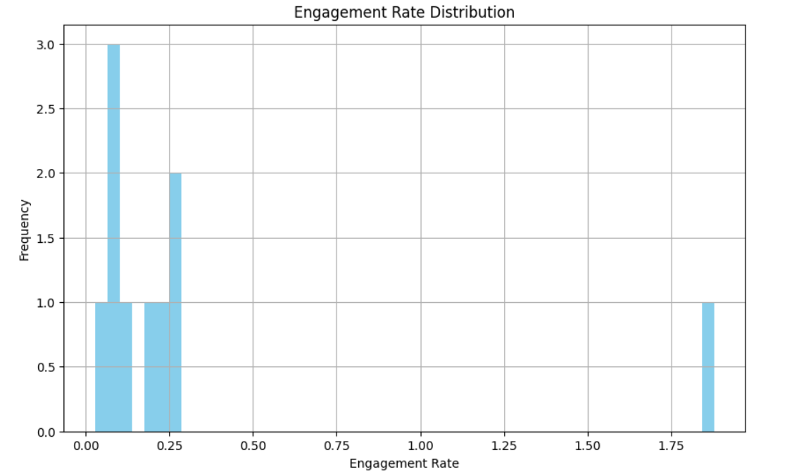

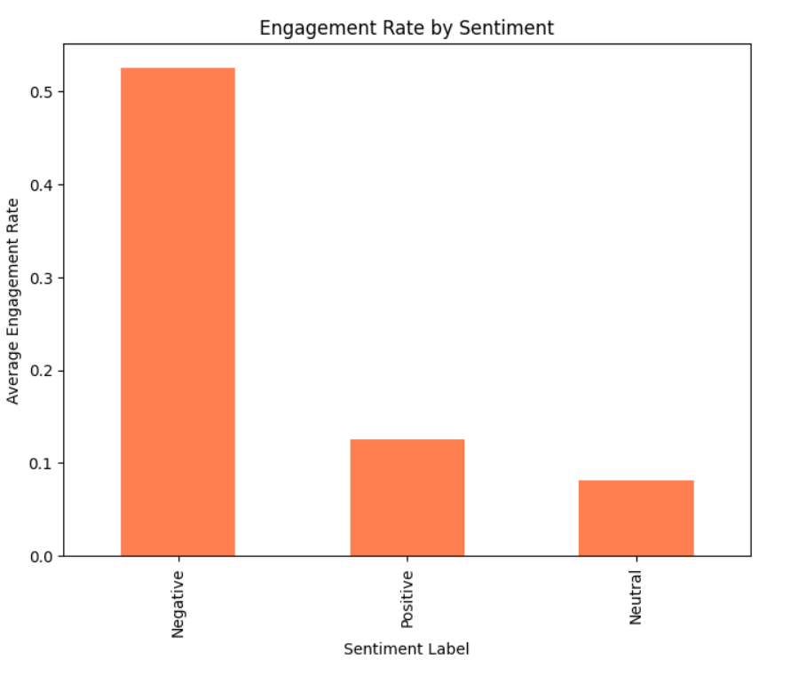

#### Task 3: Model Training

* **Status**: In Progress
* **Details**: Split the dataset into training and testing sets, fitted a linear regression model, and began evaluating model performance metrics such as Mean Squared Error (MSE) and R-squared values.

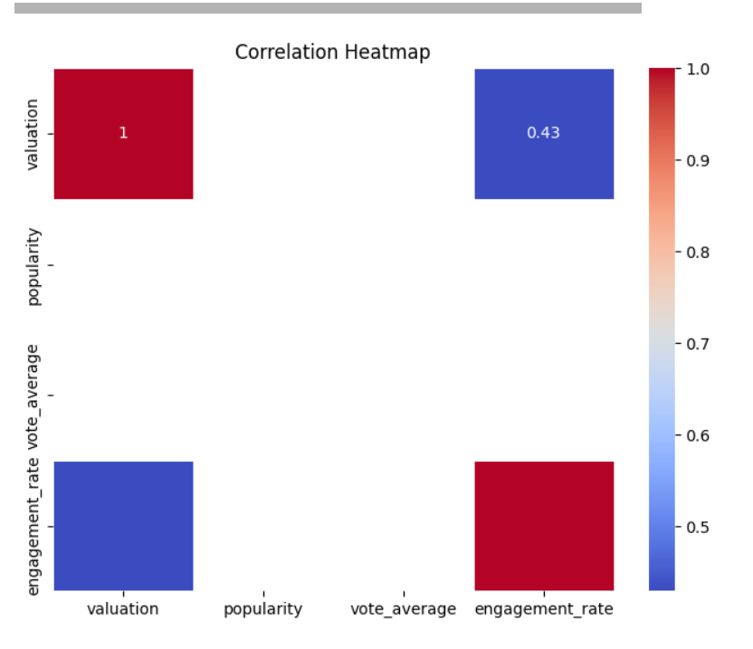

#### Task 4: Top Performing Content Identification

* **Status**: In Progress
* **Details**: Attempted to identify the top 5 most engaging pieces of content based on engagement rates, but encountered issues related to data types.

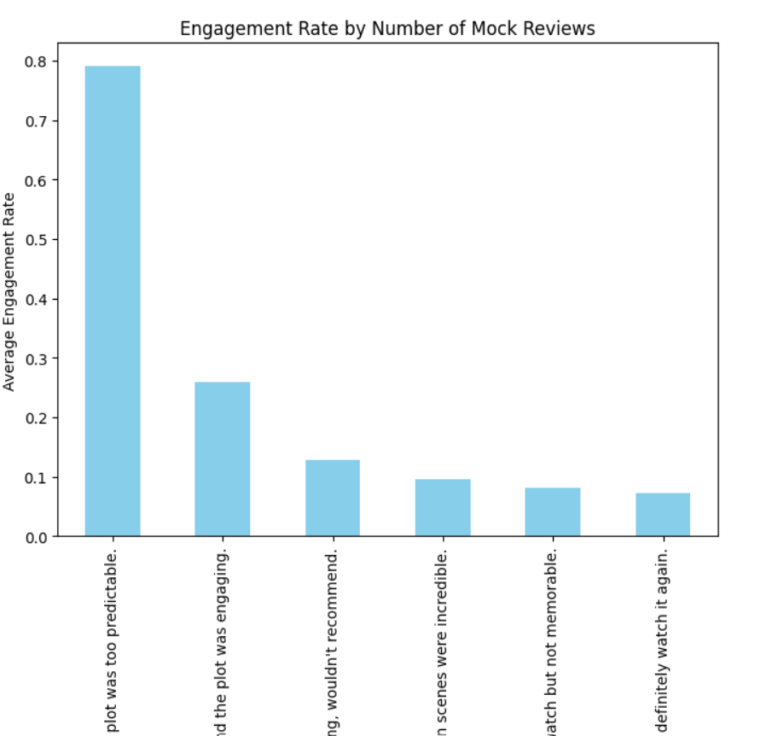

# 

**Progress :**

· **Accomplishments**: Successfully created engagement metrics and performed preliminary EDA to understand trends and patterns in engagement.

· **Metrics**: Engagement rate calculated for multiple content pieces; initial model predictions achieved.

# Challenges and Solutions :

#### Challenges Faced

* **Data Type Issues**: Encountered errors related to non-numeric data types while fitting the model, specifically with text data in sentiment analysis.

#### Solutions Implemented

* Converted relevant text data into numerical formats using techniques such as vectorization or encoding. Adjusted the dataset to ensure compatibility with model training.

# Next Steps :

* **Upcoming Tasks**: Complete model training and evaluation, finalize visualizations for EDA, and address remaining errors in top-performing content identification.
* **Goals**: Aim to refine the predictive model, generate a comprehensive report of findings, and present key insights on engagement factors.

# Conclusion :

# Summary: This report outlines the progress made in the analysis of interactive content engagement within the entertainment sector, detailing tasks completed, challenges faced, and strategies employed to overcome obstacles.

# **Acknowledgments**: Thank the audience for their time and attention.